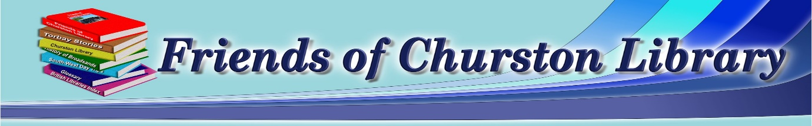
Join the Friends on Saturday 13th December for a Trip to Bristol
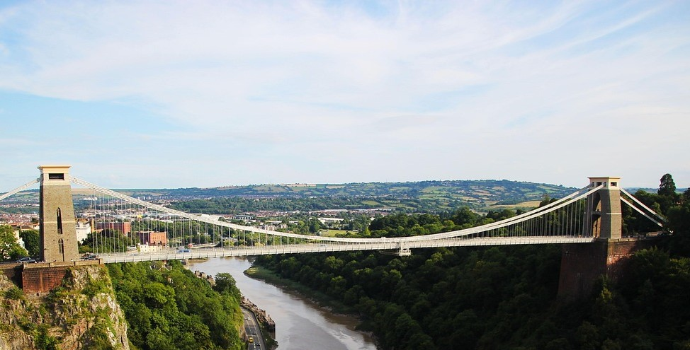
Bristol is a dynamic city, known for its rich maritime heritage, vibrant arts scene, and independent spirit. Nestled along the River Avon, it boasts iconic landmarks like the Clifton Suspension Bridge and the historic SS Great Britain. The city pulses with creativity—home to street art legend Banksy and a thriving music and theatre culture. Its harbourside buzzes with cafes, galleries, and museums like M Shed and We The Curious. Bristol also champions sustainability and community, with green spaces like Ashton Court and a strong local food movement. Whether you're exploring its Georgian architecture, quirky shops, or scenic walks, Bristol offers a perfect blend of history, innovation, and charm that makes every visit feel fresh and inspiring.
===========================================================================
Excursion Details; Pick up outside Churston Library – 8.30 Depart – Bristol 16.30
Price for members £30 – Non-members £32
Cancellations require 1 week’s notice
Applications to reach us no later than November 10th

Bristol 13th December

Number of People--------------------Membership Numbers------------------------------------------------
I enclose Cheque/Cash to the value of------------------------------------------------------------------------
Please make cheques payable to “Friends’ of Churston Library”
All payments to be left in the Friends’ box inside Churston Library. Please include your name and number in case we need to contact you.
Name-------------------------------------------------------Telephone----------------------------------------------

