

Join the Friends on Saturday 11th October for a trip to Shaftesbury

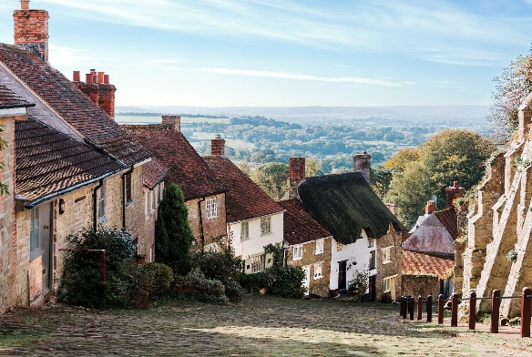
Shaftesbury, perched high on a greensand ridge in Dorset, is one of the oldest hilltop towns in the country. Founded around Shaftesbury Abbey in 888 by King Alfred, it became a significant religious and market centre. Today, it charms visitors with cobbled streets, sweeping views over Blackmore Vale, and iconic Gold Hill—immortalized in a 1970s Hovis bread advert. The town blends Saxon heritage with vibrant modern life, offering museums, festivals, and independent shops. Surrounded by the Cranborne Chase Area of Outstanding Natural Beauty, Shaftesbury is a haven for walkers and history lovers alike. Its rich past, scenic beauty, and welcoming atmosphere make it a true gem of the South West

===========================================================================
Excursion Details; Pick up outside Churston Library – 8.30 Depart – Shaftsbury 16.30
Price for members £30 – Non-members £32
Cancellations require 1 weeks’ notice
Applications to reach us no later than September 30th

Shaftsbury 11th October
Number of People--------------------Membership Numbers------------------------------------------------
I enclose Cheque/Cash to the value of------------------------------------------------------------------------
Please make cheques payable to “Friends’ of Churston Library”
All payments to be left in the Friends’ box inside Churston Library. Please include your name and number in case we need to contact you.
Name-------------------------------------------------------Telephone----------------------------------------------

